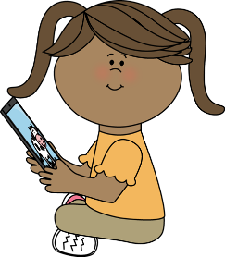
5/11 – 5/15 Digital Learning Plans
What are we learning this week?

Math  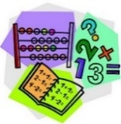 | We are learning about how to partition a rectangle into rows and columns and how to make arrays with repeated addition sentences.
Reading | We are learning about how to ask and answer questions.
Language Arts  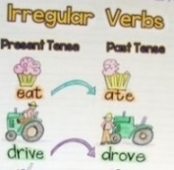 | We are learning about past tense irregular verbs. These are words that do not follow the -ed rule to make them past tense.
Science  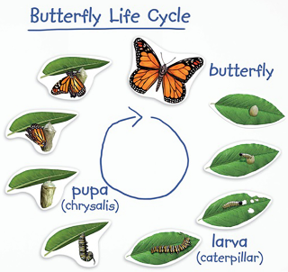 | We are learning about a butterfly’s lifecycle.

Monday | Tuesday | Wednesday | Thursday
Math  - Lesson- https://www.youtube.com/watch?v=NurOlgZgP2k  - Paper and pencil needed. Send picture to your teacher of problem #2.  - Extension- Dreambox or Moby Max  Reading  - Lesson – https://youtu.be/sm5nAcqWmJU  - Write about it: When have you had to work hard for something you want and need?  - Paper and pencil needed.  Language Arts  - Lesson – https://www.youtube.com/watch?v=t-y9Y9kvUxk  - Activity – Log-In to Moby Max to complete the assignment  www.mobymax.com/signin/conklin22  - Extra support and examples: https://bit.ly/359VWEI  Writing  - Lesson - https://youtu.be/ZicUGTvmw6k  - Activity – Write an opinion piece about why your mom is the best mom in the whole world.  - Extension- Create your writing into an art project to give to your mom. Want to use technology? Type your writing on a computer or tablet. | Math  - Lesson- https://www.youtube.com/watch?v=NH2zJA0eO2s  - Paper and pencil needed. Send picture to your teacher of problem #2.  - Extension- Dreambox or Moby Max  Reading  - Lesson – https://youtu.be/2uFsnkWrtz4  - Write about it: How do you help others at home?  - Paper and pencil needed.  - Extension: Headsprout and Raz Kids  Language Arts  - Lesson –https://www.youtube.com/watch?v=DSkTdGjM5q8  - Activity – Log-In to Moby Max to complete the assignment  www.mobymax.com/signin/conklin22  - Extra support and examples: https://bit.ly/359VWEI  Science  - Lesson – https://cobb.mackinvia.com/  - Log into Pebble Go and type in Monarch Butterflies in the search box.  - Watch the Article  - Activity- Complete the “Share what you know activity”  - Extension- Under the “Read More” Tab. Read the book A Butterfly’s LifeCycle. | Math  - Lesson- https://www.youtube.com/watch?v=Nt4ICBTdiXI  - Paper and pencil needed. Send picture to your teacher of problem #2.  - https://jr.brainpop.com/math/multiplicationanddivision/arrays/  - Extension- Complete My Math Vol.1 workbook pages 128-132  Reading  - Lesson – https://youtu.be/1PQxU3icNCs  - Write about it: In what ways are you different and special.  - Paper and pencil needed.  - Extension: Headsprout and Raz Kids  Language Arts  - Lesson –https://www.youtube.com/watch?v=4be5ARBawVU  - Activity – Log-In to Moby Max to complete the assignment  www.mobymax.com/signin/conklin22  - Extra support and examples: https://bit.ly/359VWEI  Science  - Lesson – Discovery Education Animals Life Cycle: Butterflies  - Activity- Log into Mackinvia. Scroll to and open Discovery Education. Watch the assigned video  Extension- https://cobb.mackinvia.com/  Click on Ebooks on the right.  Type “Becoming a butterfly” in the search box. Read the story. | Math  - Lesson- https://www.youtube.com/watch?v=MbV0GfstSmU  - Paper and pencil needed. Send picture to your teacher of problem #2.  - https://jr.brainpop.com/math/multiplicationanddivision/repeatedaddition/  - Extension- Complete My Math Vol.1 workbook pages 134-138  Reading  - Lesson – https://youtu.be/Mp3bKxYtnMM  - Write about it: How do you show kindness to others?  - Paper and pencil needed.  - Extension: Headsprout and Raz Kids  Language Arts  - Lesson –https://www.youtube.com/watch?v=6IyuhZUhLcY  - Activity – Log-In to Moby Max to complete the assignment  www.mobymax.com/signin/conklin22  - Extra support and examples: https://bit.ly/359VWEI  Science  - Lesson – Brainpop Jr. “Butterflies” Movie  - Log in through Clever  - Activity- After watching the Movie, complete the Quiz  - Extension- Complete the Write about it Activity. Imagine you are a butterfly. Write a story about your life.
Friday - Review and complete all assignments to make sure they are complete. Upload a picture of your work or a recording to your Dojo portfolio.

______________________________________________________

_______________________________________________________________________________________________________________________________________________________________________________________________________________________________________________________________________________________________________________________________________________________________________________________________________________________________________________________________________________________________________________________________________________________________________________________________________________________________________________________________________________________________________________________________________________________________________________________________________________________________________________________________________________________________________________________________________________________________________________________________________________________________________________________________________________________________________________________________________________________________________________________________________________________________________________________________________________________________________________________________________________________________________________________________________________

