Dear Panther Family,

Please read the following information about your child’s behavior expectations while at school. This letter includes the expectations, rewards for positive behavior, and consequences for rule breaking.

Powers Ferry Panthers School Wide Expectations
We put our best “P.A.W.S.” forward every day. Teachers help students remember these expectations by saying the acronym “P.A.W.S.”.

P. – Positive Attitude
A. – Act Respectfully
W. – Work Hard
S. – Stay Safe

This year Powers Ferry has decided to use PAWS Bucks for our school wide behavior plan for the school common areas. Students have opportunities for rewards on a daily, weekly, and monthly basis. In our classroom, we use a clip chart and Class Dojo. I enjoy Class Dojo’s many features, and encourage you to sign up if you haven’t already. Please see the chart on the back of this page for more information.

Please contact me if you have any questions or concerns about our school wide or classroom behavior systems.
- Mrs. Conklin
School Wide System (PBIS) | Classroom Clip Chart | Classroom System
Students have daily, weekly and monthly goal to earn PAWS Bucks. Students’ goal is to earn 5 PAWS bucks in the common areas every day. Any teacher or staff in the building can give out PAWS Bucks. Monthly prizes can be “purchased” from a school store. Students earn bucks for following school expectations in the following common school areas:  - Bathroom  - Hallway  - Cafeteria  - Media Center  Consequences: Students are given up to 3 reminders for a particular behavior (i.e. talking in the hallway) in one day before a parent is notified. If a negative behavior becomes consistent, then administration may get involved. | 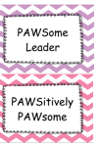  $1  $2  $3  $4  $5  $0, and denied privileges  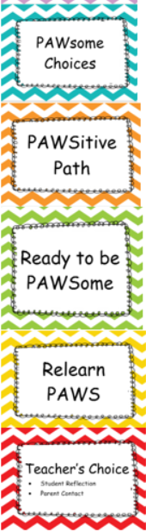 | Students begin each day on “Ready to be PAWSome”. Students will have opportunities to earn a “clip” up for positive behavior, or earn a “clip down” for negative behavior. Students are always given one verbal warning about a negative behavior before being asked to move their clip. The students earn PAWS bucks based on where their clip is at the end of the day.  The bucks can be “traded” for various prizes once a week, usually Fridays.  Consequences: If a child’s clip is on “Relearn PAWS” or “Teacher’s Choice” the student may be denied privileges (i.e. recess, technology use, etc.). Consequences and their severity are based on each situation individually.
The Dojo Connection
I use Class Dojo to connect all these different areas. During the school day, it can be time consuming to manage all of the physical PAWS bucks. I use Dojo as a way to document that the student has followed the expectation and has earned a buck in a time effective way. Students will have their points traded for bucks and reset each week so they can make reward purchases.

